MEASUREMENTS PROJECT
Ntsako K. Manyike
School of Electrical & Information Engineering, University of the Witwatersrand, Private Bag 3, 2050, Johannesburg, South Africa
Abstract: Design of a smart piezoelectric transducer to measure the impulse forces on an impact crusher in a coal mine. A model 204C ICP® dynamic force sensor piezoelectric transducer is used as a sensing element. Signal conditioning is achieved by using a charge amplifier, voltage amplifier, a second order Butterworth filter and an anti-aliasing filter with an aliasing error of less than 1% and sampling frequency of 1 MHz. A microprocessor processes the output signal and displays the computation of the force on a LCD. The frequency response of the complete system is 40 kHz with an input range of 4 - 90 kN. Intrisic safety is implemented by conforming to the IEC 60079-11, standard on coal mine electricity safety in terms of installation and protective material for the electronics. The IEC 60079-10-2 standard for electrical equipment protection in a coal mine is also adhered to in the design.
Key words: Piezoelectric sensor, impulse, smart transducer, anti-aliasing, intrinsic safety.

Introduction
Dynamic forces can be found in various industrial and research applications such as process monitoring, material testing, motion control, quality assurance and crash testing. In industrial applications, such as coal gas stoves, steam locomotives etc., where coal is often used as a resource, impact coal crushers are used to reduce the size of the raw coal to a predetermined size before further processing.
The process of coal crushing, like most industrial processes, has dynamic forces that can be measured to monitor the effectiveness of the impact crusher in reducing coal size, the amount of wear and tear on the crusher and ultimately the outcome of the crushing process \cite{Arnold:2007} When the coal strikes the crusher plate on an impact crusher, the resulting force is characterized by its peak value and the time duration \cite{Serway:2008}. The pulse generates the input frequency spectrum whose magnitude is determined by the mass of the coal and the velocity with which it is moving when it hits the structure. A dynamic force measurement system is a significant tool that is used to monitor the effectiveness, the amount of wear and tear on the crusher, crusher stall and hence the outcome of the crushing process. The measurement system has to be capable of measuring this impulse force accurately and reliably.
In order to measure the impulse force exerted by the coal particles on the impact crusher, a piezoelectric measurement system is used. Piezoelectric sensors exploit the direct piezoelectric effect to convert a force into an electrical charge \cite{Serway:2008}. This charge is the input to the instrumentation chain to ultimately produce the measurement of the impact force. Piezoelectric devices are a very reliable and inexpensive means of converting mechanical force into electrical energy and exhibit a high tolerance to environmental factors such as electromagnetic fields and humidity.
The aim of the project is to design a piezoelectric smart transducer to measure the impact force on a crusher plate. Section II gives the background of the application and comparisons between methods of measuring impact forces. Section III outlines the working principles of a piezoelectric sensor. Section IV gives a full model and description of the measurement system. System analysis is provided in Section V.

BACKGROUND
The measurement system is required to produce a signal that is proportional to the force applied when a mass of coal strikes the impact crusher plate. The system should also enable the real time observation of impact values for each instance of contact between a mass of coal and the impact crusher plate. The sensor is assumed to be placed in the middle of the crusher plate and only impacts that are within the sensor area are measured. It is also assumed that the collisions are perfectly elastic and that the coal weighs less than 5 kg. In order to calculate the bandwidth and the average forces that are expected to be exerted on the impact crusher plate by a mass of coal, impulse calculations are used with ∆v ≈ 100 km/h and a contact time of t = 0.67 ms, the process bandwidth is found to be 1.5 kHz and forces of approximately 56 kN are exerted on the crusher plate.
Several sensors can be used to measure such forces. A strain gauge measurement can be used to measure applied force. A strain gauge is an element that provides a variation in resistance in response to a dimensional change \cite{Bentley:2005}. A Wheatstone bridge is used to measure the relative change in resistance. One of the disadvantages of this method of measurement is that four sensors have to be used to obtain an accurate measurement and requires temperature compensation.
An optical interferometer was used for determining impact forces in \cite{Yusaku:2001}. The instantaneous value of the impact force is measured as the inertial force acting on the mass by measuring the instantaneous acceleration of the coal mass. This method of measurement requires complex signal conditioning circuitry and doesn’t offer the same simplicity that comes with the piezoelectric sensor \cite{Che:1996}.
Piezoelectric sensors can easily measure up to several tens of kHz above those that can be measured by strain gauges due to their higher magnitude of stiffness \cite{Metz:2005}. This is well beyond the usable frequency of most strain gauge load cells.
Piezoelectric technology is insensitive to electromagnetic fields and radiation, enabling measurements under harsh conditions. Piezoelectric sensors have been known to exhibit extreme stability even at high temperature. The advantage of piezoelectric sensors compared with other types of sensors are their long life without aging, high sensitivity, low threshold, wide measuring range, practically displacement-free measurement, high natural frequency and a wide temperature range amongst other things \cite{Yusaku:2006}.

PRINCIPLE OF OPERATION
Piezoelectricity refers to the generation of electric polarity in dielectric crystals when subjected to mechanical stress \cite{Arnau:2004}. The applied stress displaces the anion charges towards the centre of the element causing the outer faces of the element to become charged. The element generates a charge that is proportional to the mechanical stress applied. This is called the direct piezoelectric effect which is important when measuring forces. The opposite effect is also possible where a voltage applied to the crystal causes a mechanical displacement; this is known as the indirect piezoelectric effect. The element is used in its direct piezoelectric effect mode in this application. The piezoelectric effect can only happen in non-conducting materials. Piezoelectric materials for sensor elements must exhibit very high mechanical strength and rigidity above all else.
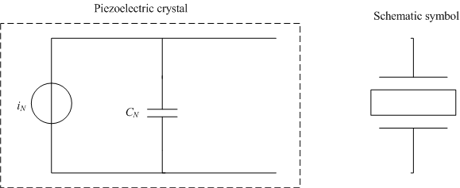
Figure 1: Norton equivalent circuit of sensor
When under stress, the element produces a charge, q, that can be measured by depositing metal electrodes on opposite faces of the element. In this configuration, the element acts like a capacitor in parallel with a current source as shown in Figure 1. The magnitude of i_{N} (the Norton current) is:
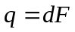 (1)
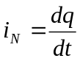 (2)
Where:
F = Force applied on the element [N],
d = is the charge sensitivity to force [CN⁻¹].
Equation (1) shows the direct piezoelectric effect where a charge is generated in response to an applied force. This shows that the force measurement only depends on the structure of the element and the reason why piezoelectric sensors are sturdy, have an extremely high natural frequency and an excellent linearity over a wide amplitude range \cite{Yusaku:2001}.
When a load is connected across the Norton equivalent circuit in Figure 1, dynamic forces can be measured by measuring the voltage across the load. The electrical path formed by the load allows the capacitor to discharge through the load. In the circuit in Figure 1, direct current is a constant force while a dynamic force is represented by an alternating current. This means that constant or slowly varying forces will tend not to cause any current to flow in the circuit while dynamic forces will cause current to flow, this is because a capacitor blocks direct current but allows alternating current to pass through. This shows that piezoelectric elements are active electrical systems because they only operate effectively when a force is applied to them and they cannot be used for true static measurements \cite{Arnau:2004}.
The time-constant of the element with a load is defined as the time it takes the charge to decrease to approximately 0.37 i_{N(peak)}. The time constant for the sensor, τ_{sensor}, is determined by the capacitance C_{N} and the impedance of the load . This time constant determines the time that the capacitor will stay charged. A static force will result in a fixed amount of charges on the capacitor, C_{N}.
Based on piezoelectric technology various physical quantities can be measured and in this application the technology is used to measure the impact force. The force is applied directly on the element ensuring that an applied force specifically loads the element in one direction.

SYSTEM MODELLING
A smart transducer is a device in a measurement environment that can carry out the core functions of transduction/actuation, signal conditioning, signal conversion, computation, control, memory, and communication while also incorporating some added functionalities to support its core functions \cite{Shuma:2003}. The components of this system are shown in Figure 2 and discussed below.

System overview
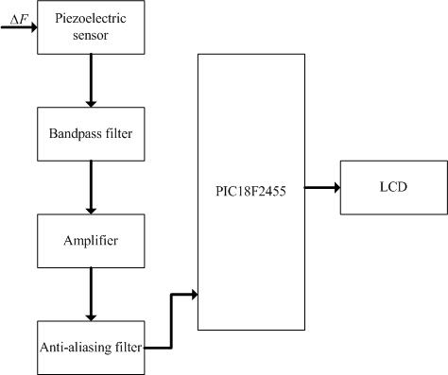
Figure 2: System overview for the impact smart transducer system.
From Figure 2, it can be seen that the piezoelectric sensor acts as the first element of the system and measures the magnitude of the measurand i.e. impact force. The output of the sensor is fed into the signal conditioning system which removes the noise signals, amplifies the signal and removes unwanted frequencies from the signal. This conditioned signal is fed into the microprocessor where it is converted from an analog signal into a digital signal that can be manipulated to get information. The information from the microcontroller is communicated using a LCD and two LED’s.

Sensing element
The sensing element acts as an interface between the measurand and the measurement system; it is in contact with and draws energy from the impact of the coal with the impact plane of the coal crusher \cite{Bentley:2005}. A common implementation practice is to sandwich a piezoelectric crystal between two metal plates to make a capacitor.
Piezoelectricity is a linear electromechanical interaction between the mechanical and electrical states of crystals with no symmetric centers \cite{ Kruglick:1999}. The piezoelectric effect results from a deformation of the crystal lattice by some external force that pushes the positive and negative lattice points against one another and thus produces a dipole moment. The resulting formation of an electric field puts an electric potential on the insulated electrodes. This results in a temporary excess of surface charge, which subsequently is manifested as a voltage which develops across the crystal. When two wires are attached to the opposite ends of the element, it can act as transducer which turns mechanical stress into electrical charge which in turn can be converted into a voltage. These piezoelectric devices generate electrical signals only in response to a change in the applied force, since under static stress free carriers drift toward the dipoles, eventually discharging the device \cite{Bentley:2005}.
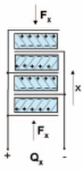
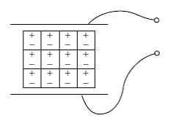(a)
V
Fx
Figure 3: Piezoelectric sensor configuration
Depending on the orientation of the axes with respect to the applied force, three different types of effect can be discerned; longitudinal, shear and transversal. These can be produced by different cutting angles. In this application, the sensor is used in the longitudinal orientation as shown in Figure 3(b).
In the longitudinal orientation, the charge output occurs at the force contact surfaces as shown in Figure 3(a), this is known as the receive mode of the sensor. The charge yield is increased by connecting n quartz disks in series with respect to the force. These disks are mechanically in series and electrically in parallel \cite{Arnau:2004}. With n disks, the charge then amounts to:
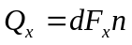 (3)
Where:
d = Piezoelectric coefficient [pC/N],
F = Applied force [N],
n = Number of crystal plates and
x = Direction of applied force.
The piezoelectric element generates a charge signal, measured in pC, that is directly proportional to the sustained force, F_{x}. In its operating region i.e. when a force is applied, a greater force will result in more surface charge. This charge results in a voltage:
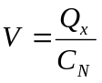 (4) Where:
Q_{x} = Charge [pC] resulting from a force F_{x} and
C_{N} = Capacitance of the element [pC].
For a piezoelectric sensor, the output voltage signal is linearly proportional to the applied external force if the piezoelectric material is in elastic deformation.
The model 204C ICP® dynamic force sensor from PCB Piezotronics, Inc is chosen. It has a sensitivity of 0.06 mV/N, a range of 0 – 90 kN and a frequency response of 0 – 55 kHz [http://www.pcb.com].

Signal conditioning
The outputs from the transducer is used as an input to the conditioning circuitry; this is done to convert the signal into a form more suitable for processing \cite{Bentley:2005}. The goal of the signal conditioning stage is to prevent amplifier saturation, minimise noise and filter out unwanted frequencies in order to facilitate signal processing \cite{Neaman:2001}. The conditioning block has three stages; charge-to-voltage conversion, voltage amplification and filtering. These stages are discussed in the following subsections.
Charge amplifier: The purpose of the charge amplifier is to convert the high impedance charge q from the sensor into a proportional voltage. In order to achieve this, amplifier acts as an integrator that constantly compensates the sensor’s electric charge with one of equal magnitude and opposite polarity, i.e. an inverting voltage amplifier with a high open-loop gain and capacitive negative feedback \cite{Neaman:2001}. Charge mode amplification is used when the amplifier is remote to the sensor as is the case in this application. Advantages are that there are no electronic components contained within the sensor housing thus increasing the upper temperature limit of the sensor.
The charge amplifier is connected to the sensor by a cable that introduces turboelectric effects that affect the signal \cite{Karki:2000}. To overcome this, the charge amplifier has to have a large open loop gain and a low noise cable that is as short as possible. The sensors electrodes are connected to the amplifier in a short circuit configuration. The output of the charge amplifier is:
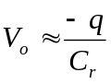 (5)
C_{r} is the range capacitor. The output of the sensor is approximately a sine wave that dampens over time. Also, the signal often goes negative which requires additional circuitry to make it positive so that it can be used by a microprocessor \cite{Karki:2000}.
The two most important considerations of the charge amplifier are the time constant and the drift \cite{Mack:2001}. The time constant, τ, is determined by a feedback resistor working together with a capacitor on the operational amplifier while drift is the undesirable change in output signal over time which is not a function of the impulse. Drift and the time constant simultaneously affect the output of the charge amplifier. The electrical insulation resistance of the force sensor and cable connecting to the charge amplifier should be larger than that of the feedback resistor in the charge amplifier to minimise drift. Therefore, to assure this, the force sensor connection point and cable must be kept clean and dry \cite{Karki:2000}.
The time constant is designed to be short, in the order of µs, in these ranges the time constant contributes more significantly to the output signal than drift. Additionally if the open-loop gain is sufficiently high, the cable and sensor capacitance can be neglected, leaving the output voltage dependent on just the charge at the charge amplifier input and the range capacitor justifying the assumptions made in Equation 5. Charge amplifiers also allow for the adjustment of sensor sensitivity and measuring range since the lower frequencies of the frequency response are determined by the time constant, 1/RC in Figure 3. This allows the same sensor to measure a wide range of quantities. The high frequency response is determined mechanically from the sensor design.
Frequency response is defined as a maximum specified amplitude variation, from an established reference frequency, over a specified bandwidth \cite{Parr:2003}. The high frequency response of the piezoelectric sensor approximates that of a single degree of freedom second order spring-mass under damped system. The transfer function is:
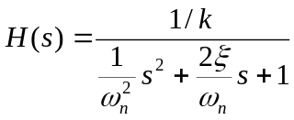 (5)
Where:
ω_{n} = 2πf_{n},
ξ = Damping ratio.
The resulting frequency response diagram is shown in Figure 3. The natural frequency, f_{n}, of the quartz element occurs far above the normal working bandwidth range of the application. As the natural frequency is approached, the frequency response of the sensor increases logarithmically as can be seen in Figure 3. It is a rising response, rather than a decreasing response that limits the frequency response at the upper limit, f_{n}. This is the reason piezoelectric sensors are ideal for measuring forces which change rapidly over time as in this application \cite{Arnau:2004}. The inherent high frequency limit of the sensor is a function of its mechanical characteristic.
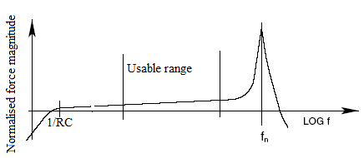
Figure 3: Typical frequency response with charge amplifier.

The high rigidity of piezoelectric sensors results in the highest possible natural frequencies. It is desirable to have a uniform frequency response over the specified frequency range. This is the wide range of useful frequencies that piezoelectric sensors are known for. As can be seen, Figure 3, the sensitivity begins to rise rapidly as the natural frequency of the sensor is approached. It can be seen that the sensitivity rises as the frequency increases. For most applications, it is generally acceptable to use this sensor over a range where the sensitivity deviates by less than +5%, labelled usable range in Figure 3. This upper frequency limit occurs at approximately 20% of the resonant frequency \cite{Mack:2001}.
The time constant τ, determines the discharge time and the low frequency response analogous to the action of a first order high-pass RC filter as shown in Figure 3. This filtering characteristic is useful for draining off low frequency signals generated by thermal effects on the transduction mechanism. If allowed to pass, this could cause drifting, or in severe cases, saturate the amplifier in the next stage.
Voltage amplifier: The gain of the voltage amplifier is governed by the maximum allowable input voltage range of the microprocessor which is 0 – 5 V. The voltage amplification of the sensor signal is set to 20 in order for the output to be in the usable voltage range. A TLV2771 amplifier is chosen to achieve due to its high slew rate of 10 V/µs and bandwidth up to 5.1 MHz. A fast slew operational amplifier is required in to reduce time delays in the system and the high bandwidth limit allows the system to be kept within the minimum applications bandwidth constraint.
Filtering: To minimise the high frequency noise from distorting the signal before it is sampled, an anti-aliasing filter is added. A second order Butterworth bandpass filter is designed to filter out all unwanted frequencies, and only pass the required frequencies to the microprocessor. The quality factor for this filter is chosen to be 1, to avoid overshoots \cite{Parr:2003}. The choice of filter is due to the fact that the frequency of interest is known beforehand. So a bandwidth of 2 kHz is chosen to allow only 1% pass band error. The filter will provide 40 dB/decade attenuation at frequencies above the system bandwidth and that is sufficient to reduce the out of band frequencies that can degrade the ADC conversion. The bandwidth of the filter is designed so as to only let through the impulse force signals and filter out low frequency vibrations and noise that come through due to the wide frequency band of the sensor.
An analogue low pass filter is used for anti-aliasing to filter out high frequency noise prior to analogue conversion to minimise undesired aliasing harmonics. The analogue filter also protects the ADC’s modulator from saturation due to noise peaks. The Butterworth design is chosen because it has the flattest possible magnitude pass-band \cite{Neaman:2005}. Therefore the magnitude of the signal will not be modified and should there noise spikes superimposed to the signal they will be removed.
The anti-aliasing filter is designed to have an aliasing error of 1% at a cut off frequency of 0.5 MHz. The cut off frequency is chosen to satisfy the Nyquist sampling theorem. To implement the filter, an LM 358 low power dual operational amplifier supplied by National Semiconductor is used. It can be supplied from a 5 V source, has low input offset voltage and a cut off frequency of 0.5 MHz [http:// http://www.national.com/en/].
The filter is designed so as to satisfy the Nyquist criterion and the signal is sampled at a sampling frequency that is more than twice the cut-off frequency. The transfer function equation used for the design is:
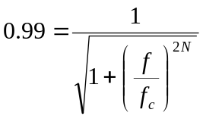 (6)
Where the 0.99 is chosen to achieve a 1% aliasing error. The system is a 4th order system, N = 4 and the sampling frequency for the system is found to be 98 kHz which is sufficient for the application since its more than twice the applications frequency, 25 kHz, thereby satisfying the Nyquist criterion.

Signal processing
The signal processing element converts the output of the conditioning element into a form easily communicated to the user \cite{Bentley:2005}. It does this by also performing suitable computations on the digitised signal. The signal processing element consists of a microcontroller with an inbuilt analog-to-digital converter (ADC) witch samples the signal from the conditioning element.
The speed at which the ADC and precision is performed form the core of the microcontroller selection. Essentially the requirements for microcontroller chip are a build in ADC, high operating speeds (in the MHz range), and a reasonable bit count.
For the microcontroller to process the signal from the conditioning element it has to be sampled and digitised by the ADC. The ADC uses the principle of sample and hold to convert the acquired analogue signal into digital form. The ADC samples the signal in equal increments of time. Aliasing results when the sampling frequency is lower than twice that of the signals’ highest frequency. This is because a certain portion of the signals’ energy will reside in the bandwidth of the previous sample and a fold over will form between the samples resulting in an erroneous signal being recovered from the sampled data \cite{Parr:2003}. To avoid under-sampling it is recommended that Shannon’s sampling theorem is adopted and a sampling frequency more or equal to twice the highest frequency component in the signal is used. Over-sampling is also advised in order to mitigate the noise floor of the system since an anti-aliasing filter is used \cite{Parr:2003}.
A PIC18F2221 microprocessor is used to process the signal. It features a 13 channels 10-bit ADC, 2 comparators, the synchronous serial port that can be configured as either 3-wire Serial Peripheral Interface or the 2-wire Inter-Integrated Circuit bus, 8 – 40 MHz internal RC oscillator, advanced low power oscillator controls and a sampling speed of 100k samples per second which maximises precision and minimises the quantization error. The input voltage range of the microprocessor is 0.6 - 5 V if a 5V supply is used with a resolution of 2.4 mV/bit. Since the signal conditioning circuitry’s response time is the slowest with respect to the other electronic devices in the circuit design, the system bandwidth is dominated by the sensors’ bandwidth is designed to be at 50 kHz. The sampling frequency of the microcontroller was chosen to be twice the anti-aliasing filter frequency of 1 MHz for the analog input. It is programmed in C to compute the force from a given input charge from the equation:
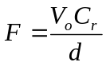 (7)
With F the magnitude of the measured force, C_{r} and d as before.

Data presentation
The measured value of the force is communicated via a Liquid Crystal Display (LCD). A Samsung KS066u is selected for this application. A red LED is also used as a means of communication, which indicate impulse forces that are within 10% of the maximum or minimum which alerts the operator to machine malfunction. Under normal circumstances the green LED is always activated.
Safety: The SABS standard, SANS 10108:2005, classifies a coal crushing environment as a zone 21 fiery environment. Measures should be taken when installing electrical equipment in such environments. The sensor complies to this because it is constructed with smooth, parallel quartz plates and a hermetically sealed, stainless steel housing. Adequate measures must be taken to ensure that power supplies are correctly fitted and that the sensor is integrated into the system efficiently to minimize safety hazards such as sparks {#Find SABS Standard}.

SYSTEM ANALYSIS

Static characteristics
Table 1: System static characteristics
Parameter | Value
Sensitivity | 2.39 mV/N
Input range | 2 – 80 kN
Output range | 0 – 5 V
Resolution | 3.28 %

Errors
Errors arise due to environmental noise and long term drift due to component tolerances. The system error is computed by considering the worst-case effects of components on the output voltage of the system, i.e. component tolerances for the passive components and quantisation error for the ADC using:
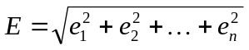 (8)
The overall system error is calculated using (8) with n being the error at each stage of the n stages of the system. All resistors are 0.1% precision metal film resistors and capacitors are rated 1% 25 V. The overall system error is obtained to be 13.5 % with a maximum power dissipation of 6.2 W by calculating the power losses due to tolerances.

Dynamic characteristics
When a system is subjected to an input change, it does not instantaneously change the output to a new value. The way in which an element responds to sudden input changes is termed its dynamic characteristics.
Time response: The rise time of the force sensor must be faster than the expected contact time between the mass of coal and the impact plate to measure the value of the force accurately. Rise time is defined as the time it takes a force sensor to rise from 10% to 90% of its final value when subjected to a step input. It is complicated to compute the rise time for force sensor applications because mounted natural frequency depends on the particular application. The more mass on top of the sensor, the lower the natural frequency \cite{Arnold:2004}.
This dynamic model is computed with the assumption that the bandwidth of the microcontroller and the display can be considered to be small when compared to the sensor and filter bandwidth. Thus these components can be modelled by zero order systems with unity gains. The time response of the system before the signal processing stage is given in Figure 4.
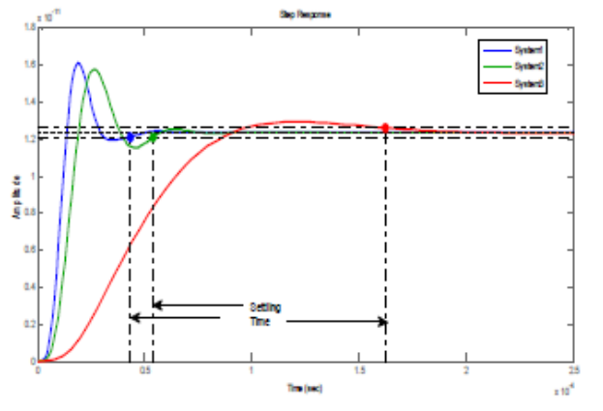
Figure 4: System time response
The system is an under-damped system largely due to the sensors damping ratio in Equation (9), system 1 is the response of just the sensor. The settling time is within that of the required, i.e. T_{s} < 0.67 ms, System 2 in Figure 4. System 3 represents a critically damped system with 0.2 % overshoot but the settling time is more. The required system bandwidth of 1.5 kHz is satisfied by the 0.55 ms settling time.
The bandwidth of the system is also considered by cascading the transfer function of the sensor, the gain of the amplifier and the transfer function of the lowpass filter. The frequency response of the system is shown in on the Bode plot in Figure 5.
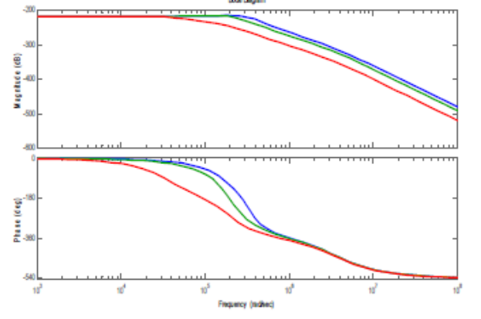
Figure 5: Bode plot of the dynamic response of the system.

Conclusion

References
- Bentley J. P., “Principles of Measurement Systems”, Pearson Education Limited, 2005.
- Phillips C. L., Parr J M, Riskin E A. “Signals, Systems and Transforms”. Pearson Education Inc, USA, 2003.
- Neamen D. A., “Electronic Circuit Analysis and Design”, McGraw-Hill Companies Inc, USA, second edition, 2001.
- Horowitz P. and Hill W., “The Art of Electronics”, 2nd ed, Cambridge University Press, USA, 1989.
- Shuma-Iwisi M. V. and Gibbon G. J, “Smart Transducers: A reconstructed definition and a link to microcontrollers”, First African control conference (AFCON 2003), Cape Town, 2003.
- Metz, R., “Automotive Component Durability Testing using Quartz Piezoelectric Force Sensors,” Automotive Testing Expo, 2005.
- Che W. S. and Oh J. H., “Development of force-balance accelerometer with high accuracy for precision motion measurement”. IOP Publishing Ltd, 1996.
- Jewett Jr J. and Serway R.A., “Physics for Scientists and Engineers with Modern Physics”, Thomson Learning, Inc. Belmont, Seventh edition, 2008.
- Fujii Y and Valer J. D. R., “Impact force measurement using an inertial mass and a digitize”, Vol. 17, 2006, pp 863–868.
- Mack, O., “New procedures to characterize drift and non-linear effects of piezoelectric force sensors.” Proceedings of the 17th IMEKO TC3 Concerence, Istanbul (Turkey), 17.-21. Sept. 2001.
- Kruglick E. J. J. and Pister K. S. J., "Lateral MEMS Microcontact Considerations", IEEE Journal of Microelectromechanical Systems, Vol. 8, 1999, pp. 264-271.
- Fujii Y., “Measurement of impulse response of force transducers”, American Institute of Physics, Vol. 72, 2001, pp. 3108-3111.
- Arnold J.B., Klima M.S., Bethell J.P., “Designing the coal preparation plant of the future.” SME, 2007.
- Vives Antonio A., Arnau Antonio, “Piezoelectric transducers and applications”, Springer, 2004, pp 1-207.
- Karki James, “Signal Conditioning Piezoelectric Sensors”, Application report: Mixed Signal Products (SLOA033A), 2000, pp 1- 6.

